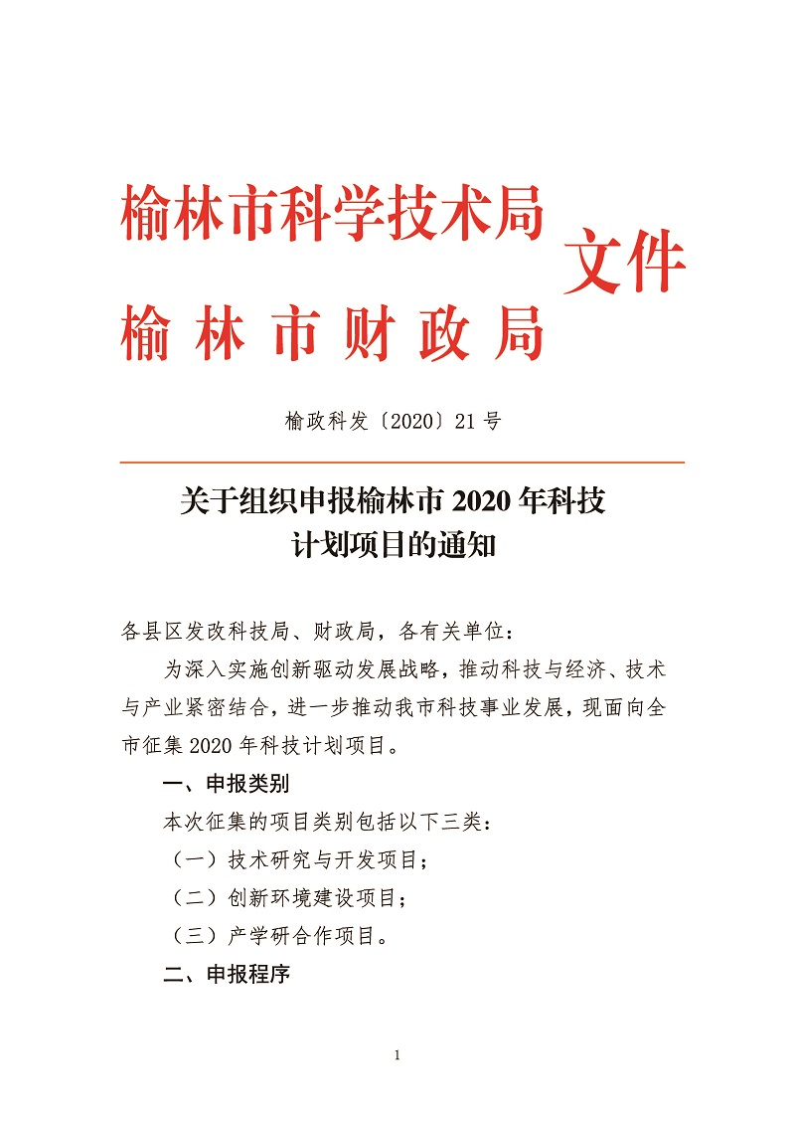

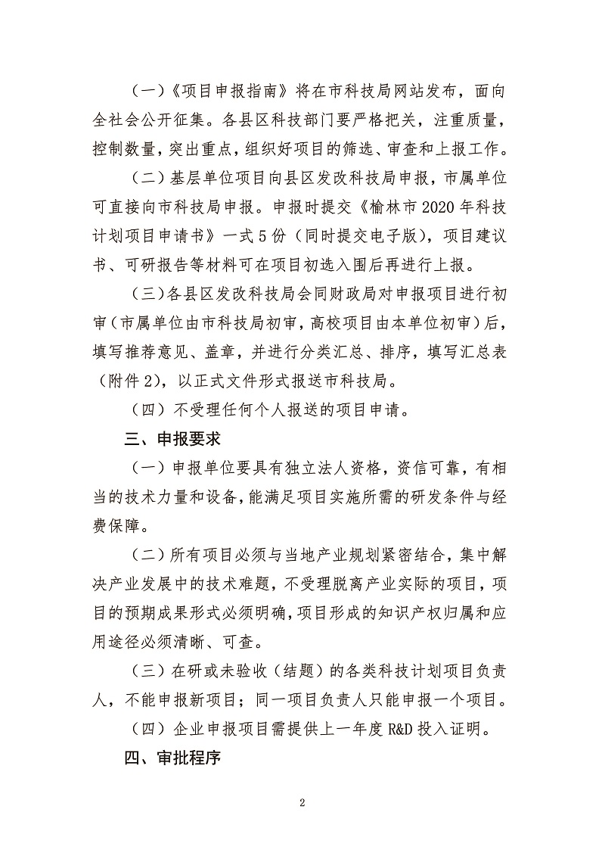

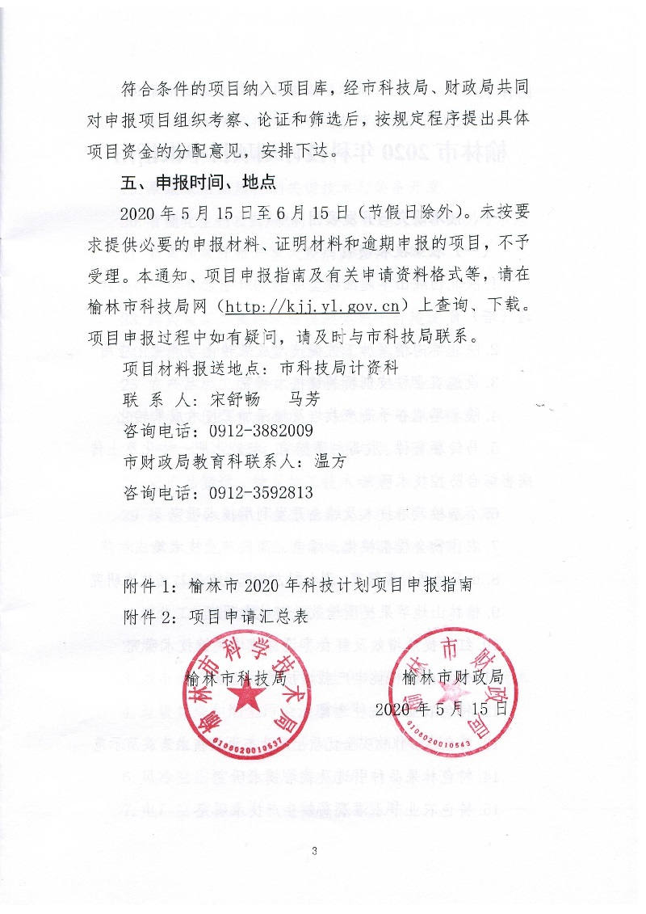

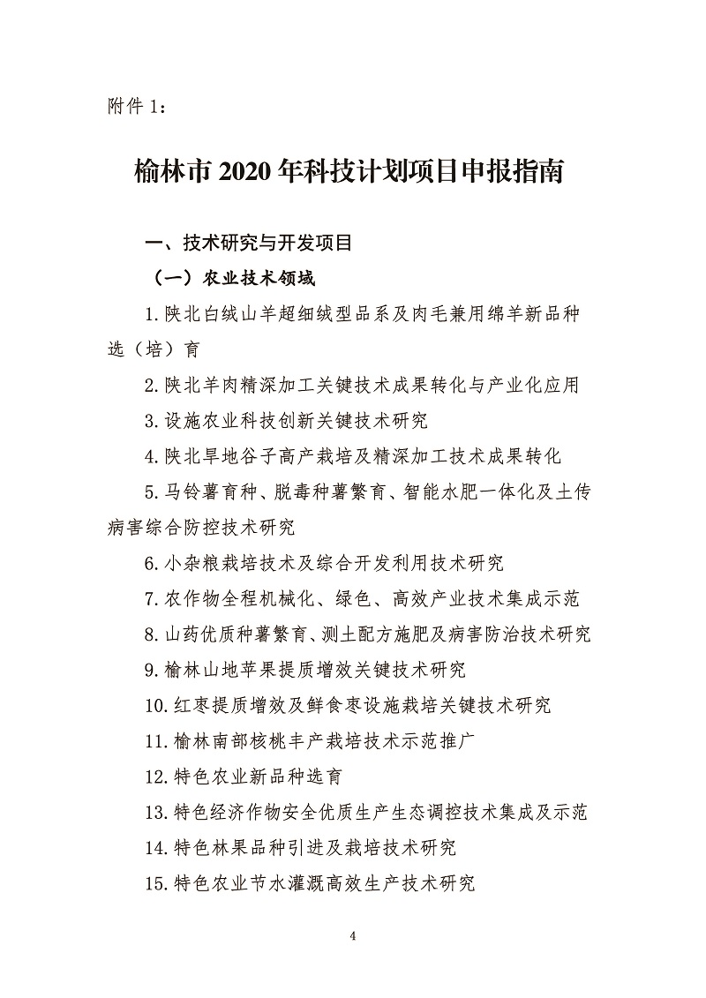

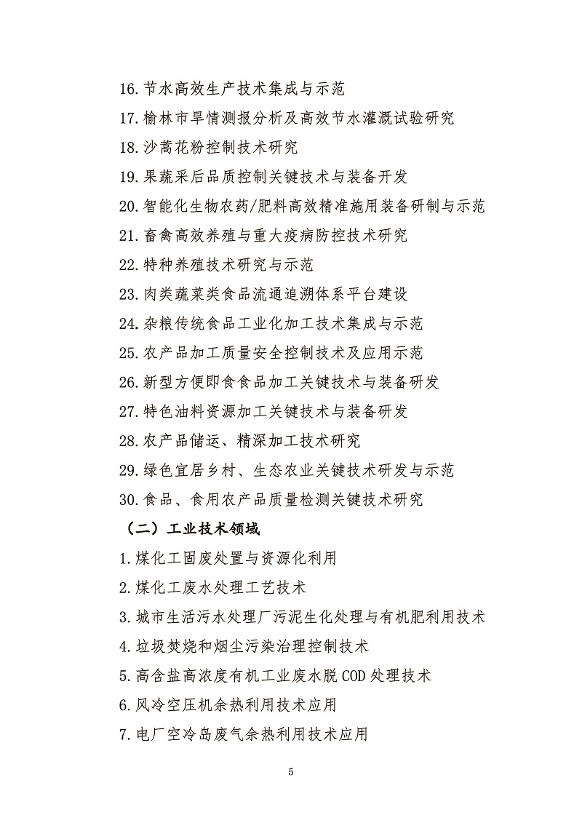

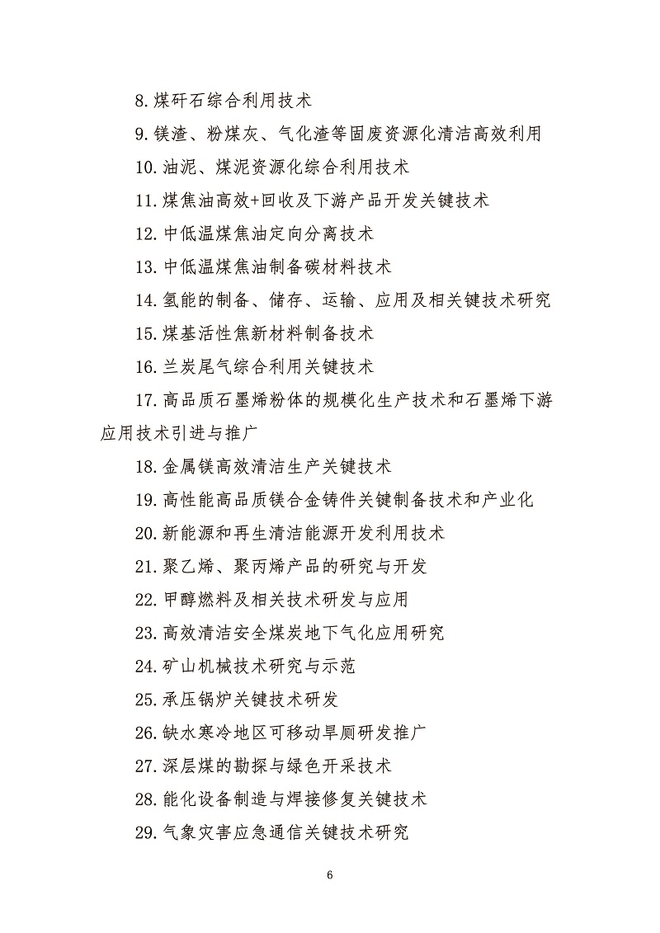

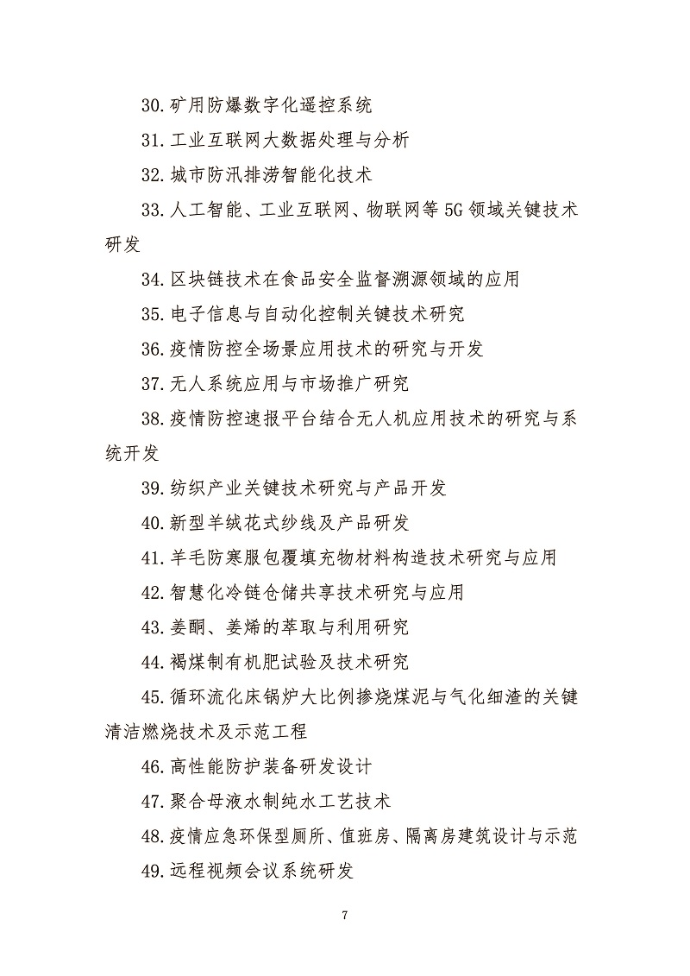

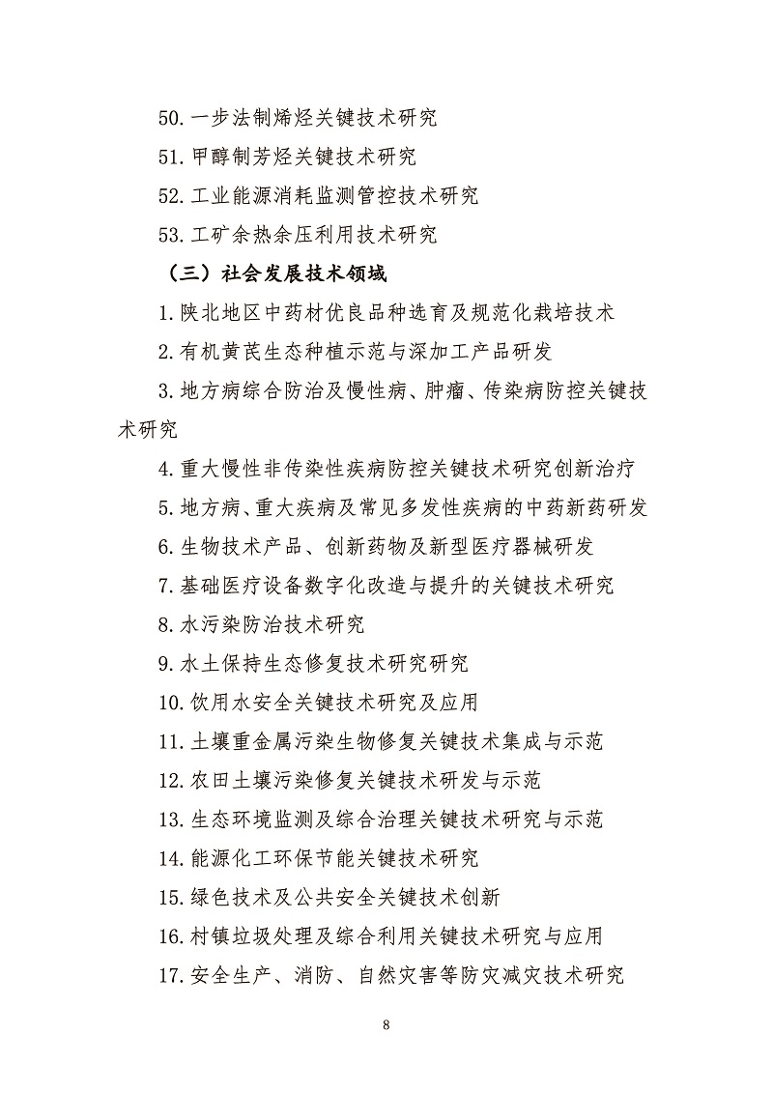

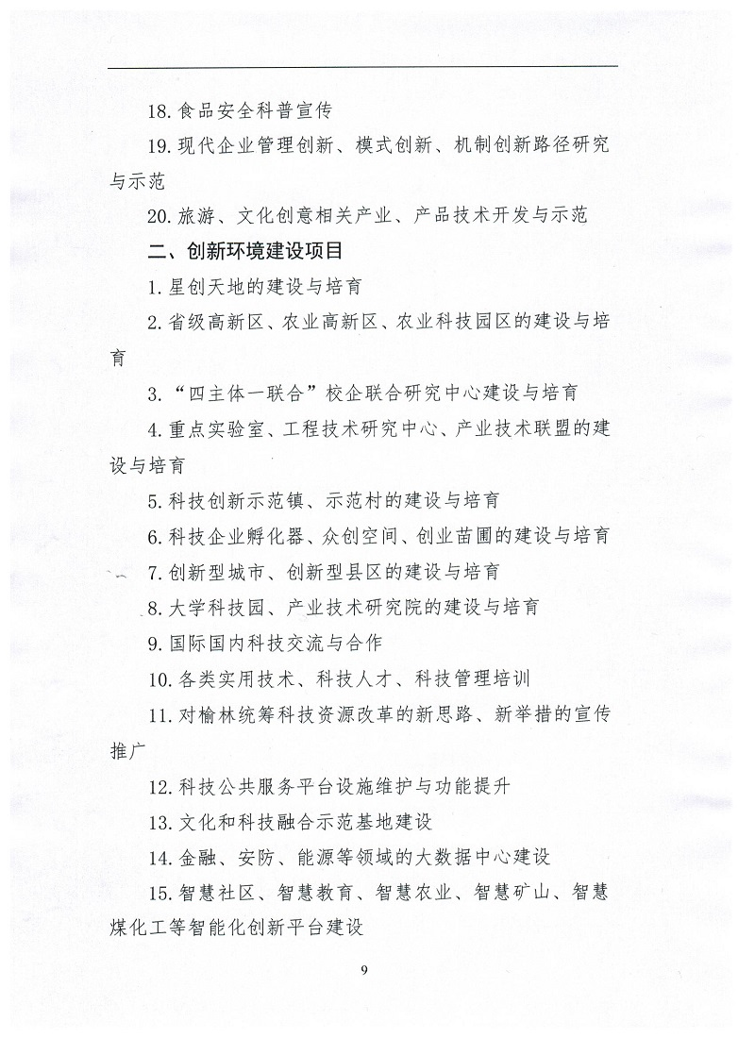

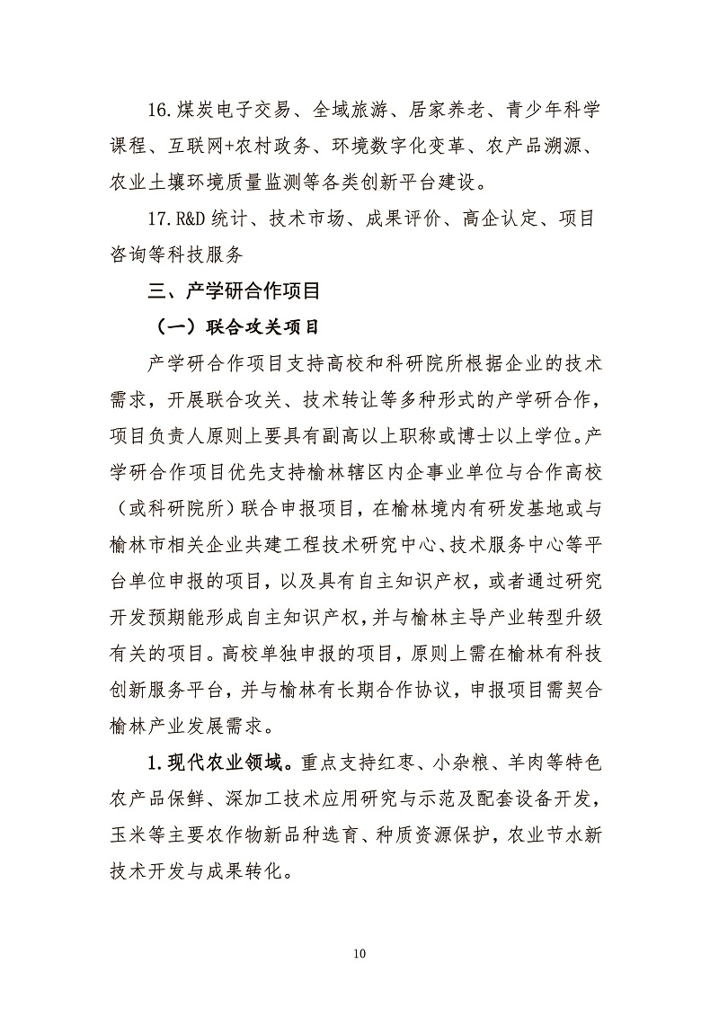

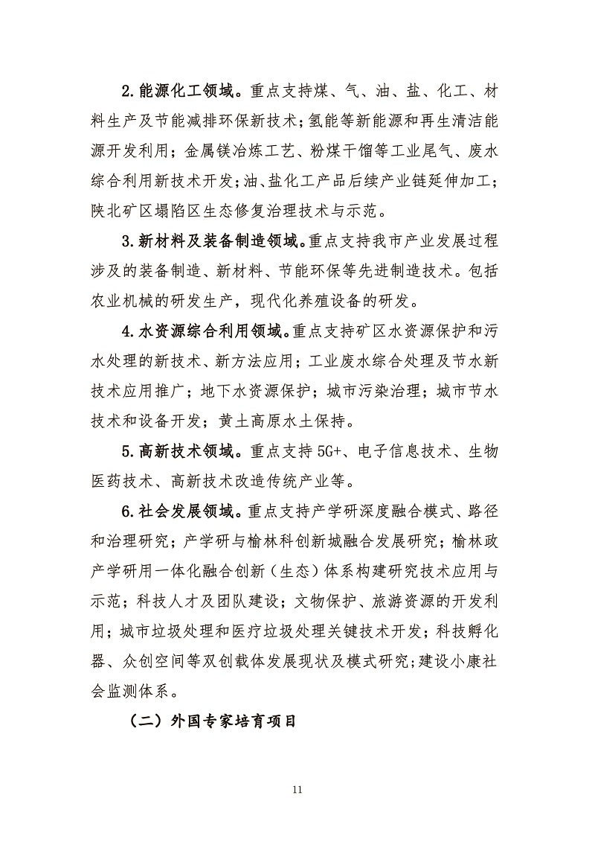

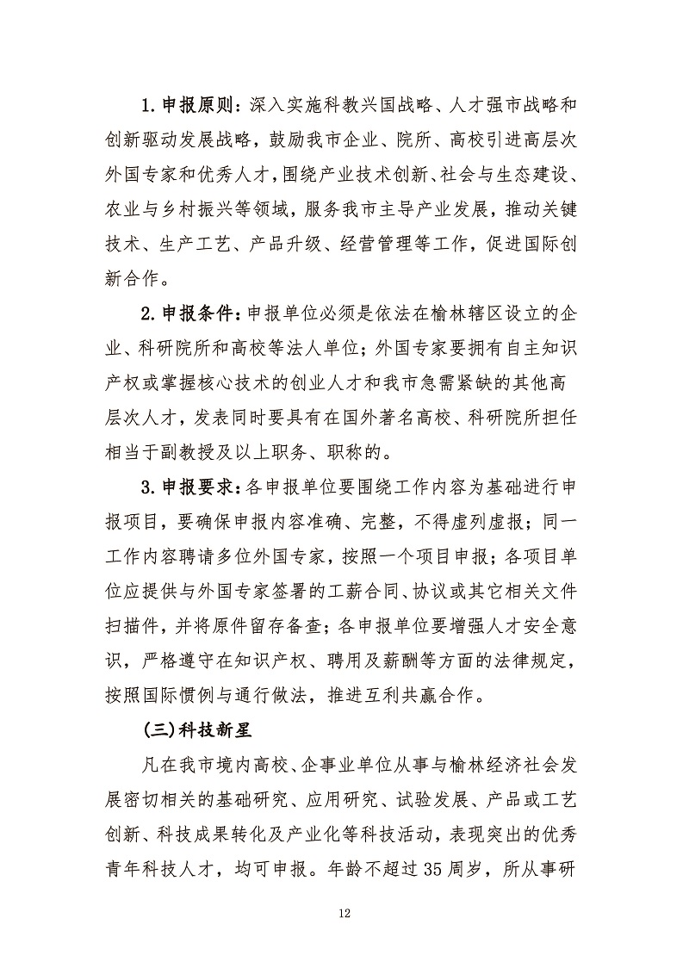

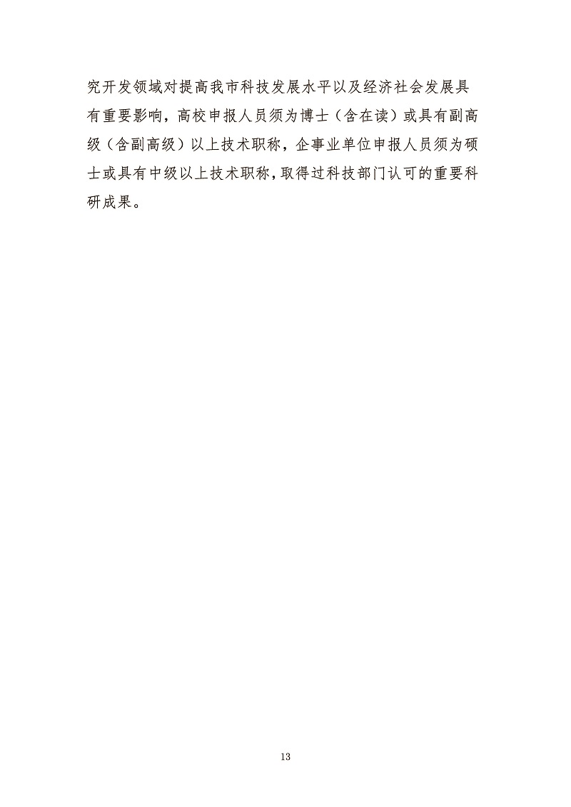

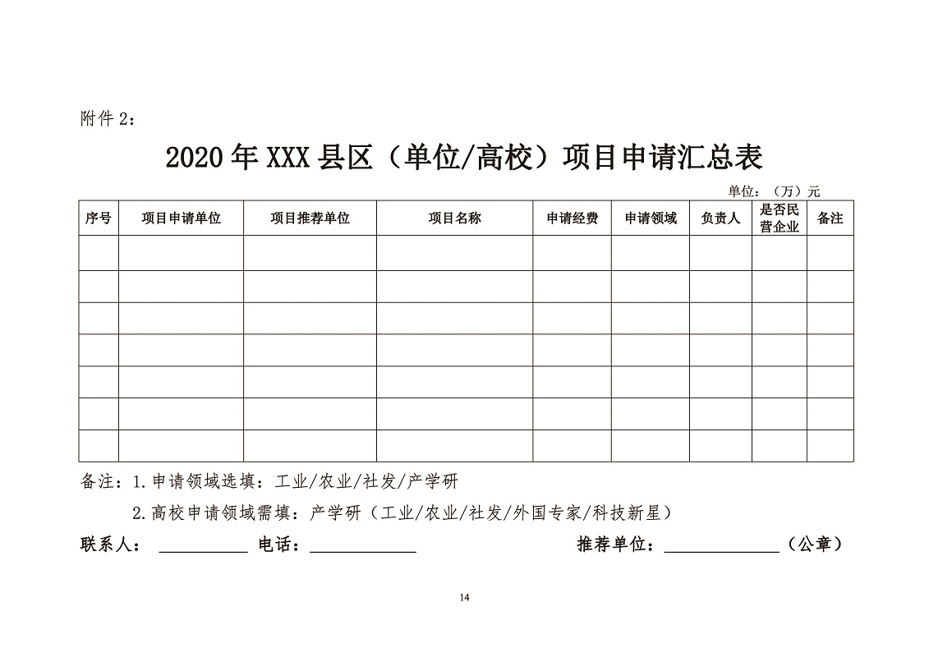

附件：[榆林市2020年科技计划项目申请书.docx](http://kjj.yl.gov.cn/upload/file/%E6%A6%86%E6%9E%97%E5%B8%822020%E5%B9%B4%E7%A7%91%E6%8A%80%E8%AE%A1%E5%88%92%E9%A1%B9%E7%9B%AE%E7%94%B3%E8%AF%B7%E4%B9%A6.docx)  
[榆林市2020年项目申请书汇总表.docx](http://kjj.yl.gov.cn/upload/file/%E6%A6%86%E6%9E%97%E5%B8%822020%E5%B9%B4%E9%A1%B9%E7%9B%AE%E7%94%B3%E8%AF%B7%E4%B9%A6%E6%B1%87%E6%80%BB%E8%A1%A8.docx)  
[榆林市工程技术研究中心建设项目申请书.doc](http://kjj.yl.gov.cn/upload/file/%E6%A6%86%E6%9E%97%E5%B8%82%E5%B7%A5%E7%A8%8B%E6%8A%80%E6%9C%AF%E7%A0%94%E7%A9%B6%E4%B8%AD%E5%BF%83%E5%BB%BA%E8%AE%BE%E9%A1%B9%E7%9B%AE%E7%94%B3%E8%AF%B7%E4%B9%A6.doc)  
[榆林市农业星创天地建设项目申请书.docx](http://kjj.yl.gov.cn/upload/file/%E6%A6%86%E6%9E%97%E5%B8%82%E5%86%9C%E4%B8%9A%E6%98%9F%E5%88%9B%E5%A4%A9%E5%9C%B0%E5%BB%BA%E8%AE%BE%E9%A1%B9%E7%9B%AE%E7%94%B3%E8%AF%B7%E4%B9%A6.docx)  
[榆林市青年科技新星项目申请书.doc](http://kjj.yl.gov.cn/upload/file/%E6%A6%86%E6%9E%97%E5%B8%82%E9%9D%92%E5%B9%B4%E7%A7%91%E6%8A%80%E6%96%B0%E6%98%9F%E9%A1%B9%E7%9B%AE%E7%94%B3%E8%AF%B7%E4%B9%A6.doc)  
[榆林市外国专家引进培育项目申请书.docx](http://kjj.yl.gov.cn/upload/file/%E6%A6%86%E6%9E%97%E5%B8%82%E5%A4%96%E5%9B%BD%E4%B8%93%E5%AE%B6%E5%BC%95%E8%BF%9B%E5%9F%B9%E8%82%B2%E9%A1%B9%E7%9B%AE%E7%94%B3%E8%AF%B7%E4%B9%A6.docx)  
[榆林市重点实验室建设申请书.docx](http://kjj.yl.gov.cn/upload/file/%E6%A6%86%E6%9E%97%E5%B8%82%E9%87%8D%E7%82%B9%E5%AE%9E%E9%AA%8C%E5%AE%A4%E5%BB%BA%E8%AE%BE%E7%94%B3%E8%AF%B7%E4%B9%A6.docx)